**Lab 1**

**Isa Dzhumabaev.**

Program is a solution for online judge problem:

<https://www.urionlinejudge.com.br/judge/en/problems/view/1568>

Solution is based on prime numbers and made using Eratosthenes sieve. As first step algorithm finds all prime numbers from 0 to 1 000 000, then program factorizes the input number and counts quantity of its factors, this quantity will be the answer.

**Source code:**

#include "stdio.h"

#include "inttypes.h"

#define N 1000000

int findPrimes(int*);

int main(int argc, char** argv)

{

int primes[N];

int p = findPrimes(primes);

int64_t n;

**while**(scanf("%lld", &n) != EOF) {

**if**(n == 0) {

printf("1**\n**");

**continue**;

}

**while**(n % 2 == 0) {

n /= 2;

}

int r = 1;

int i = 0;

**while** ( i < p && n != 1) {

int count = 0;

**while**(n % primes[i] == 0) {

n /= primes[i];

count++;

}

r *= count + 1;

i++;

}

r *= n != 1 ? 2 : 1;

printf("%d**\n**", r);

}

**return** 0;

}

int findPrimes(int* primes) {

char s[N] = { 0 };

primes[0] = 2;

int p = 1;

int i = 2;

**while** (i < N)

{

**if**(s[i] == 0) {

primes[p++] = i;

int j = i;

**while** (j < N) {

s[j] = 1;

j += i+i;

}

}

i++;

}

**return** p;

}

Program was tested using Perf profiling.

**Result:**

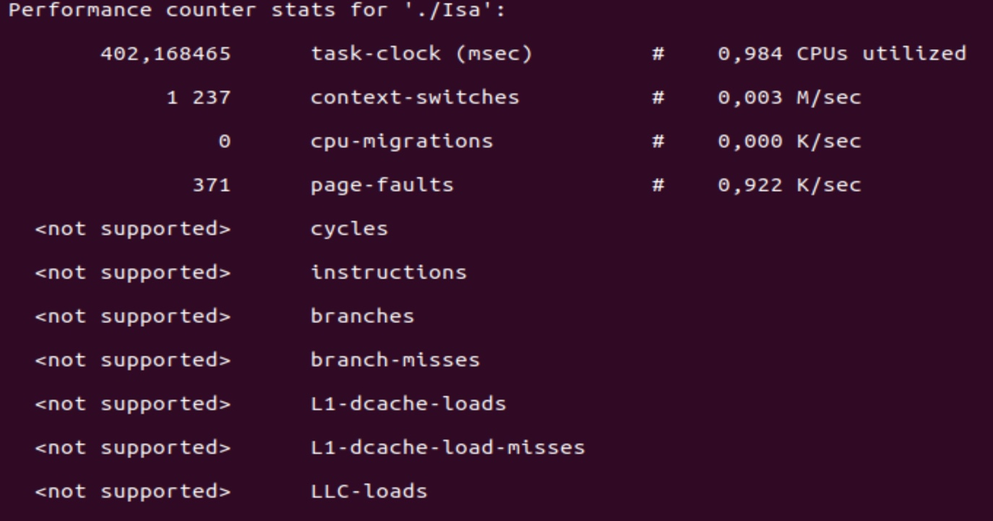

**Input:**

899999640000011

899998380000053

899998200000059

899997780000073

899997660000077

899997060000097

899996940000101

899996580000113

899996400000119

899996160000127

899995140000161

899994900000169

899994540000181

899993700000209

899993280000223

899993160000227

899992080000263

899991840000271

899991180000293

899990940000301

899990760000307

899989860000337

899989380000353

899987880000403

899987700000409

899987400000419

899987160000427

899986800000439

899986500000449

899986440000451

899985960000467

899985900000469

899985360000487

899985180000493

899985060000497

899984340000521

899984280000523

899983980000533

899983380000553

899983260000557

899982000000599

899981940000601

899980860000637

899979840000671

899979780000673

899978880000703

899978760000707

899978160000727

899977800000739

899977140000761

899976000000799

899972580000913

899972460000917

899972040000931

899971860000937

899998080000583

899997900000649

899997480000803

899997360000847

899996760001067

899996640001111

899996280001243

899996100001309

899995860001397

899994840001771

899994600001859

899994240001991

899993400002299

899992980002453

899992860002497

899991780002893

899991540002981

899990880003223

899990640003311

899990460003377

899989560003707

899989080003883

899987580004433

899987400004499

899987100004609

899986860004697

899986500004829

899986200004939

899986140004961

899985660005137

899985600005159

899985060005357

899984880005423

899984760005467

899984040005731

899983980005753

899983680005863

899983080006083

899982960006127

899981700006589

899981640006611

899980560007007

899979540007381

899979480007403

899978580007733

899978460007777

899977860007997

899977500008129

899976840008371

899975700008789

899972280010043

899972160010087

899971740010241

899971560010307

899996640003127

899996220003869

899996100004081

899995500005141

899995380005353

899995020005989

899994840006307

899994600006731

899993580008533

899993340008957

899992980009593

899992140011077

899991720011819

899991600012031

899990520013939

899990280014363

899989620015529

899989380015953

899989200016271

899988300017861

899987820018709

899986320021359

899986140021677

899985840022207

899985600022631

899985240023267

899984940023797

899984880023903

899984400024751

899984340024857

899983800025811

899983620026129

899983500026341

899982780027613

899982720027719

899982420028249

899981820029309

899981700029521

899980440031747

899980380031853

899979300033761

899978280035563

899978220035669

899977320037259

899977200037471

899976600038531

899976240039167

899975580040333

899974440042347

899971020048389

899970900048601

899970480049343

899970300049661

899996040004307

899995920004543

899995320005723

899995200005959

899994840006667

899994660007021

899994420007493

899993400009499

899993160009971

899992800010679

899991960012331

899991540013157

899991420013393

899990340015517

899990100015989

899989440017287

899989200017759

899989020018113

899988120019883

899987640020827

899986140023777

899985960024131

899985660024721

899985420025193

899985060025901

899984760026491

899984700026609

899984220027553

899984160027671

899983620028733

899983440029087

899983320029323

899982600030739

899982540030857

899982240031447

899981640032627

899981520032863

899980260035341

899980200035459

899979120037583

899978100039589

899978040039707

899977140041477

899977020041713

899976420042893

899976060043601

899975400044899

899974260047141

899970840053867

899970720054103

899970300054929

899970120055283

899995500005621

899994900007081

899994780007373

899994420008249

899994240008687

899994000009271

899992980011753

899992740012337

899992380013213

899991540015257

899991120016279

899991000016571

899989920019199

899989680019783

899989020021389

899988780021973

899988600022411

899987700024601

899987220025769

899985720029419

899985540029857

899985240030587

899985000031171

899984640032047

899984340032777

899984280032923

899983800034091

899983740034237

899983200035551

899983020035989

899982900036281

899982180038033

899982120038179

899981820038909

899981220040369

899981100040661

899979840043727

899979780043873

899978700046501

899977680048983

899977620049129

899976720051319

899976600051611

899976000053071

899975640053947

899974980055553

899973840058327

899970420066649

899970300066941

899969880067963

899969700068401

899994780007469

899994660007777

899994300008701

899994120009163

899993880009779

899992860012397

899992620013013

899992260013937

899991420016093

899991000017171

899990880017479

899989800020251

899989560020867

899988900022561

899988660023177

899988480023639

899987580025949

899987100027181

899985600031031

899985420031493

899985120032263

899984880032879

899984520033803

899984220034573

899984160034727

899983680035959

899983620036113

899983080037499

899982900037961

899982780038269

899982060040117

899982000040271

899981700041041

899981100042581

899980980042889

899979720046123

899979660046277

899978580049049

899977560051667

899977500051821

899976600054131

899976480054439

899975880055979

899975520056903

899974860058597

899973720061523

899970300070301

899970180070609

899969760071687

899969580072149

899994060009797

899993700010961

899993520011543

899993280012319

899992260015617

899992020016393

899991660017557

899990820020273

899990400021631

899990280022019

899989200025511

899988960026287

899988300028421

899988060029197

899987880029779

899986980032689

899986500034241

899985000039091

899984820039673

899984520040643

899984280041419

899983920042583

899983620043553

899983560043747

899983080045299

899983020045493

899982480047239

899982300047821

899982180048209

899981460050537

899981400050731

899981100051701

899980500053641

899980380054029

899979120058103

899979060058297

899977980061789

899976960065087

899976900065281

899976000068191

899975880068579

899975280070519

899974920071683

899974260073817

899973120077503

899969700088561

899969580088949

899969160090307

899968980090889

899993580011413

899993400012019

899993160012827

899992140016261

899991900017069

899991540018281

899990700021109

899990280022523

899990160022927

899989080026563

899988840027371

899988180029593

899987940030401

899987760031007

899986860034037

899986380035653

899984880040703

899984700041309

899984400042319

899984160043127

899983800044339

899983500045349

899983440045551

899982960047167

899982900047369

899982360049187

899982180049793

899982060050197

899981340052621

899981280052823

899980980053833

899980380055853

899980260056257

899979000060499

899978940060701

899977860064337

899976840067771

899976780067973

899975880071003

899975760071407

899975160073427

899974800074639

899974140076861

899973000080699

899969580092213

899969460092617

899969040094031

899968860094637

899993040013447

899992800014351

899991780018193

899991540019097

899991180020453

899990340023617

899989920025199

899989800025651

899988720029719

899988480030623

899987820033109

899987580034013

899987400034691

899986500038081

899986020039889

899984520045539

899984340046217

899984040047347

899983800048251

899983440049607

899983140050737

899983080050963

899982600052771

899982540052997

899982000055031

899981820055709

899981700056161

899980980058873

899980920059099

899980620060229

899980020062489

899979900062941

899978640067687

899978580067913

899977500071981

899976480075823

899976420076049

899975520079439

899975400079891

899974800082151

899974440083507

899973780085993

899972640090287

899969220103169

899969100103621

899968680105203

899968500105881

899992620015113

899991600019159

899991360020111

899991000021539

899990160024871

899989740026537

899989620027013

899988540031297

899988300032249

899987640034867

899987400035819

899987220036533

899986320040103

899985840042007

899984340047957

899984160048671

899983860049861

899983620050813

899983260052241

899982960053431

899982900053669

899982420055573

899982360055811

899981820057953

899981640058667

899981520059143

899980800061999

899980740062237

899980440063427

899979840065807

899979720066283

899978460071281

899978400071519

899977320075803

899976300079849

899976240080087

899975340083657

899975220084133

899974620086513

899974260087941

899973600090559

899972460095081

899969040108647

899968920109123

899968500110789

899968320111503

899991360020447

899991120021463

899990760022987

899989920026543

899989500028321

899989380028829

899988300033401

899988060034417

899987400037211

899987160038227

899986980038989

899986080042799

899985600044831

899984100051181

899983920051943